Technical Datasheet RS485 Display

RS485 Display - Module: -

This digital LED display is designed for precise industrial data visualization. With RS485 communication and Modbus RTU support, it can interface directly with PLCs and automation systems. The display shows real-time process parameters and allows configuration of settings such as baud rate, parity, and slave ID. Its durable design ensures reliable performance in demanding industrial conditions.
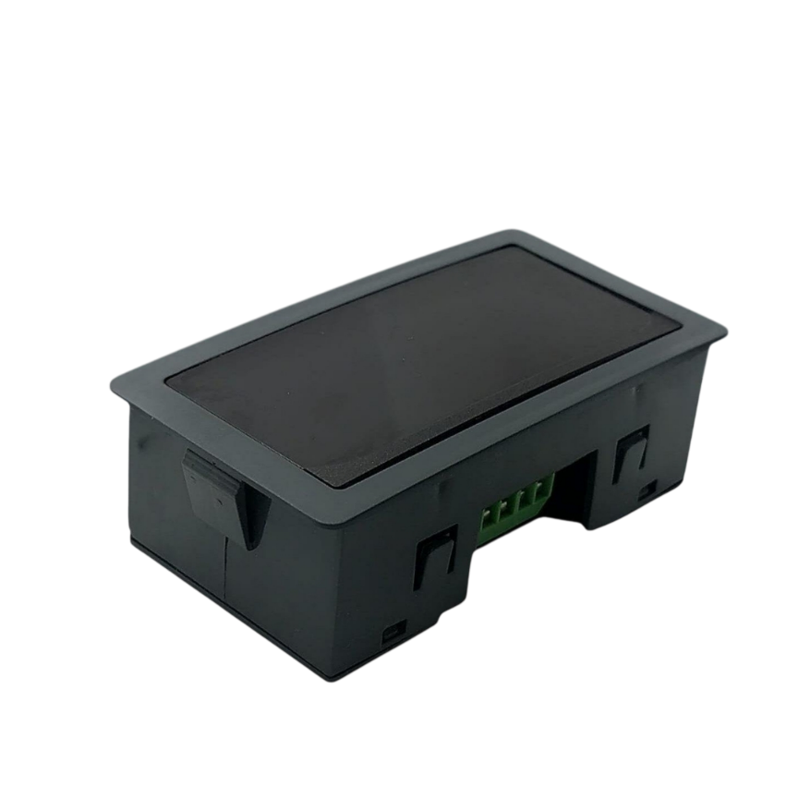
Specifications
General –
I/O Connectors 2 Pin pitch pluggable screw terminals.
Dimensions 7.6 x 3.92 x 2.15 cm
Power Input Power – 12 – 24 VDC
Typical – 12V DC @ 80mA
Operating Temperature 0 – 60° C (32 ~ 140°F)
Storage Temperature -20 - 70° C (-4 ~ 158°F)
Storage Humidity 5 ~ 95 % RH, non – Condensing
Certifications 

Display Specification:

Type 7 Segment/ 14-Segment.
Digit Count 4 Digit.
Digit Height 0.56 inch / 0.14mm.
Color Red.
Update Rate 1Hz.
Enclosure Size 70mm x 40mm x 20mm (direct mountable in slot)

Additional Features: -

Input power reverse polarity safety
ESD Safety IEC 61000-4-2, ± 30KV contact, ± 30KV air
EFT IEC 61000-4-4, 50A (5/50ms)
750V isolation.

Configuration Settings: -

Communication Speed 9600 – 19200 Kbps (Soft Serial)
Data Bits 8
Parity None
Stop bit 1
CRC Yes
Slave ID 1-247
Function Code 0x03 Read Holding Registers

Note: -
For MODBUS communications, a shielded and twisted pair cable is used. One example of such cable is Belden 3105A.

RS485 Display Register:-
- First Register – Value to Display
- Purpose: Write the actual number you want to show on the display.
- Type: Usually a single holding register (16-bit).
- Example:
- If you want to display 1234, write 1234 to this register.
- Note: The display will update immediately when the value is written.
- Second Register – Decimal Point Selection
- Purpose: Control where the decimal point appears on the display.
- Type: Usually another holding register (16-bit).
- Example:
  - 0 → no decimal
  - 1 → 1 decimal place (e.g., 123.4)
  - 2 → 2 decimal places (e.g., 12.34)
  - 3 → 3 decimal places (e.g., 1.234)
- Note: Some displays use bitmasking, where each bit represents a DP position. Always check the datasheet.

ID | Function  Description | Register  Description | Modbus Function Code | Protocol | Data  Type
0 | Display Number | 40001 | 0X03 | RS485 | 16 Bit Unsigned int
1 | Decimal Point | 40002 | 0X03 | RS485 | 16 Bit Unsigned int
2 |  | 40003 | 0X03 | RS485 | 16 Bit Unsigned int
3 |  | 40004 | 0X03 | RS485 | 16 Bit Unsigned int
4 |  | 40005 | 0x03 | RS485 | 16 Bit Unsigned int
5 |  | 40006 | 0x03 | RS485 | 16 Bit Unsigned int
6 |  | 40007 | 0X03 | RS485 | 16 Bit Unsigned int
7 |  | 40008 | 0X03 | RS485 | 16 Bit Unsigned int
8 |  | 40009 | 0x03 | RS485 | 16 Bit Unsigned int
9 |  | 40010 | 0x03 | RS485 | 16 Bit Unsigned int
10 | Display Baud Rate (Default:960) | 40011 | 0X03 | RS485 | 16 Bit Unsigned int
11 | Enter New Baud Rate | 40012 | 0X03 | RS485 | 16 Bit Unsigned int
12 | Display Slave ID (Default:1) | 40013 | 0X03 | RS485 | 16 Bit Unsigned int
13 | Enter New Slave ID | 40014 | 0x03 | RS485 | 16 Bit Unsigned int
14 | Display Parity  (Default: None-3And for Odd-1,Even-2) | 40015 | 0x03 | RS485 | 16 Bit Unsigned int
15 | Enter New Parity | 40016 | 0x03 | RS485 | 16 Bit Unsigned int
16 | Display Stop Bit  (start-2/stop bit-1) | 40017 | 0x03 | RS485 | 16 Bit Unsigned int
17 | Enter New Start/ Stop Bit | 40018 | 0x03 | RS485 | 16 Bit Unsigned int

Note:

- In register 40015- you will able to see the current parity and you can change it in register 40016
- In register 40017- you will able to see the current stop bit and you can change it in register 40018
- If you want to enter the baud rate 9600/19200/38400/57600/115200etc.
Enter it as 960/1920/5760/11520etc.
- After that press the reset button or reboot the system.

BAUD RATE and SLAVE ID DESCRIPTION:

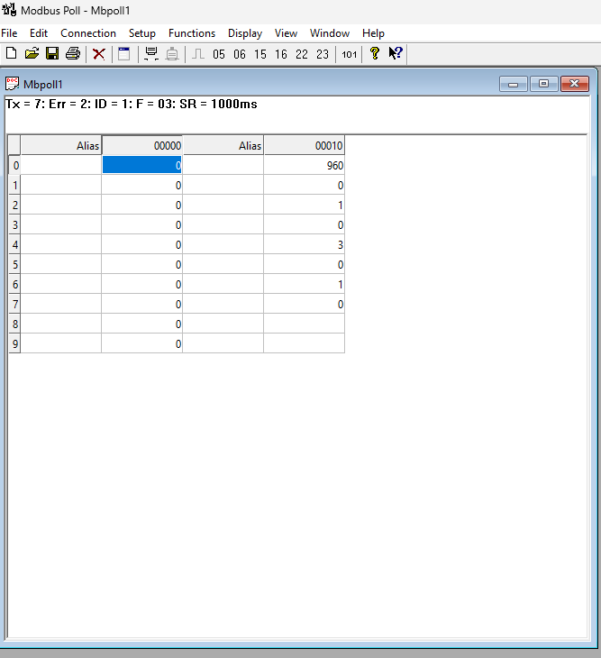

As you can see in the image above, the resistor 40011 – 960 represents the present bund rate (9600) of the board and 40013 – 1 represents the present slave id of the board.

To change the baud rate and slave id you have to enter a value on the 40012 resistor for the baud rate and 40014 for the slave id as shown in the image below.

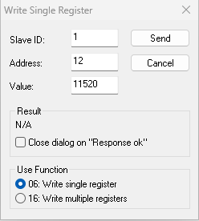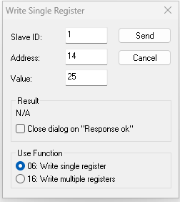

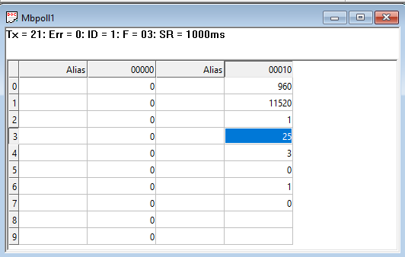

As you can see in the image above I set 115200 baud rate and slave ID 25.
Note:
1. If you want to enter the baud rate 9600/19200/38400/57600/115200etc.
Enter it like this 960/1920/5760/11520etc.
2. After that press the reset button or reboot the system.
3. Then you will get the present value of 11520 at 40011 baud rate(115200) and 25 at 40013 slave id.
4. You can Change Parity Bit , stop bit Of the device with same way.

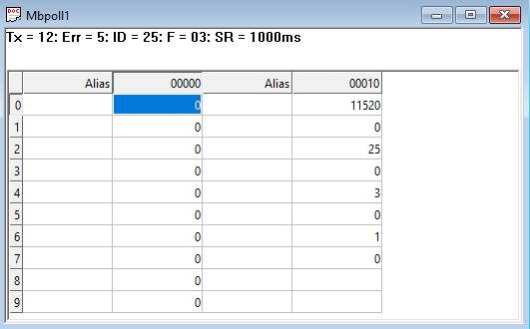

Resetting Modbus Setting
- To restore the device to its default Modbus settings:
- Pull out the jumper as shown in the image.
- Press the reset button while the jumper is removed.
- Release the reset button.
- Re-insert the jumper (if required).
- Note: This will restore all Modbus settings (ID, baud rate, parity, etc.) to factory defaults. Any custom configuration will be lost.
Recommended Cable Electrical Characteristics: -
22 AWG Cable Shielded and twisted pair should be used.
Tinned Copper Recommended
Nominal Conductor DCR 14.7 ohm / 1000 ft
Nominal Capacitance 11 pf / feet (conductor to conductor)
High Frequency Non-Insertion Loss 0.5db / 100ft

Reset
Jumper

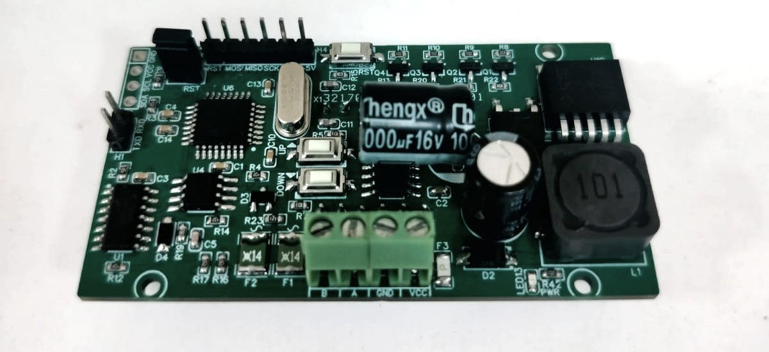
Modbus RS 485
Input12-24 VDC

Contact us: -
Augmatic Technologies Pvt. Ltd.,
Plot no 6, Shah Industrial Estate II,
Kotambi,
Vadodara – 391510.
Email – Sales@wittelb.com
Support: support@wittelb.raiseaticket.com / +91 94038 92805

